**Midterm Report**

**Team Members - Deepti Deshpande (u0872493)**

**- Josh Gross (u0915571)**

The website ratemycharity (<http://www.ratemycharity.com/>) allows users to rank charities and leave their feedback. The website will contain a list of charity categories and the corresponding major charities. Users would be able to register on the website, rate the charity, and leave user comments on how they feel about the charity. The database would contain the charity list, info, and user comments. The webpage would also have links to tweet and/or Facebook out their review.

The mock up shown below resembles the main page of our website where user will

be able to sign in/register. It will also display a list of top 5 charities and the recent news related to various charitable organizations. This page will also have a search bar where user can search for his charity to rate it or leave a feedback.

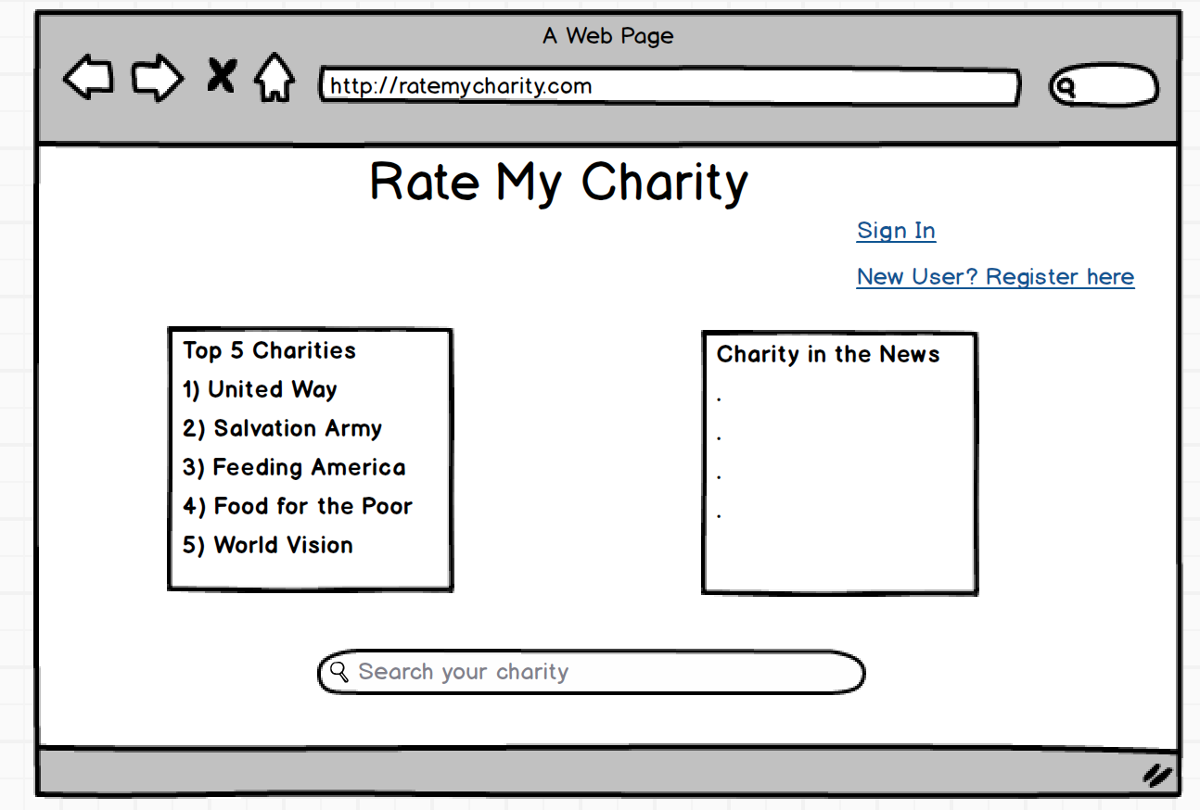

The mock up shown below resembles the sign up page of our website where user will be redirected to, for logging in on our website. This page will have text fields for accepting user’s username and password. The user will be directed back to the main page if he/she is able to login successfully.

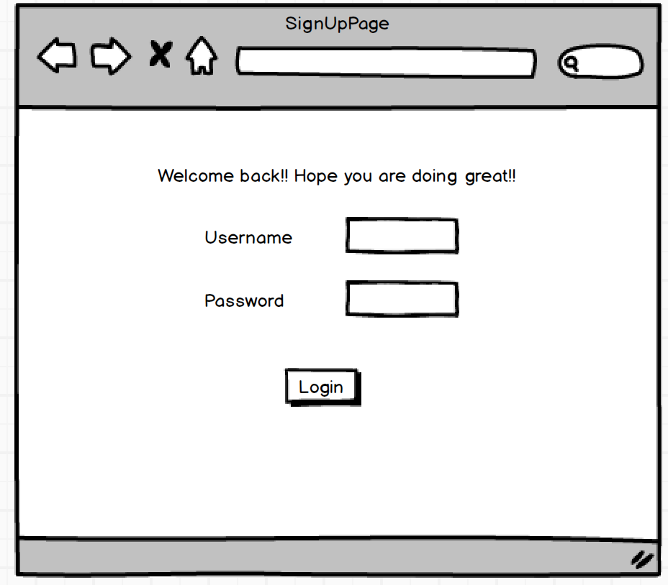

The mock up shown below resembles the register page of our website where user will be redirected to, for registering in on our website. This page will have text fields for accepting user’s username and password. We are also planning to collect some other useful data from the user, example of which is shown below. The user will be directed back to the main page if he/she is able to register successfully.

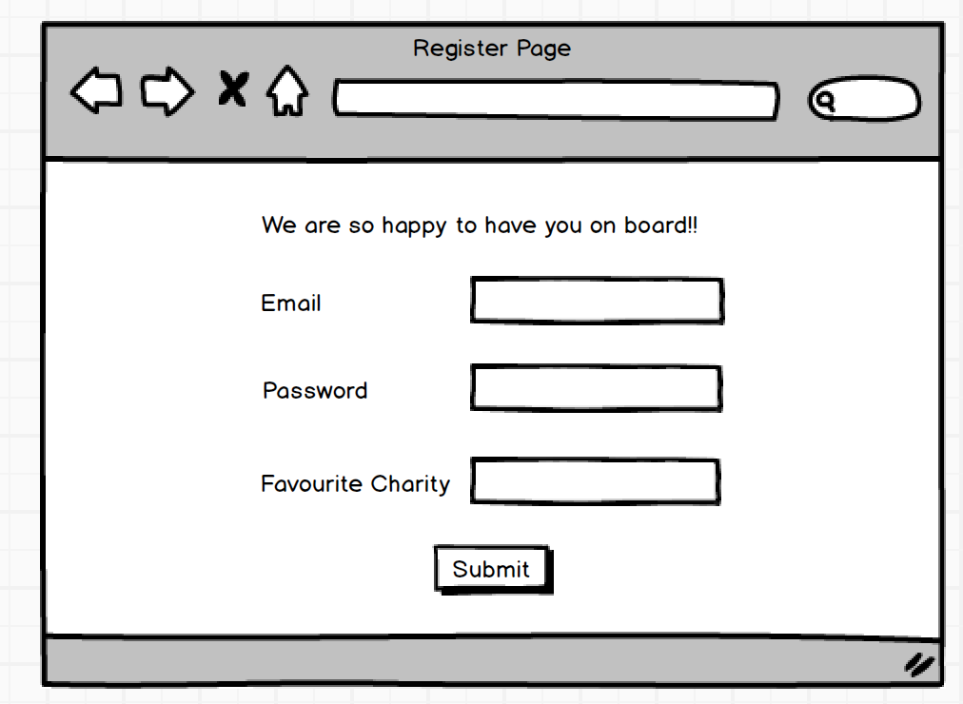

The mock up shown below resembles the search results page of our website where user will be redirected to, after he clicks on the search bar available on the main page. This page will display search results corresponding to the keyword inputted by the user on the search bar of the main page. The user will have the option of rating his charity on this page too.

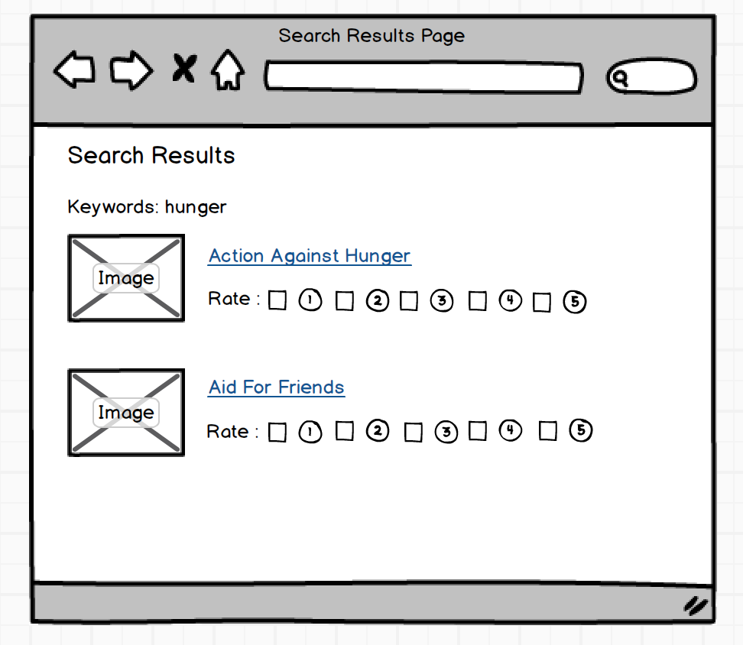

The mock up shown below resembles the page for every charity which will be listed on the website either on the main page or on the search results page. This page will display current rating of the charity. The user will have the option of rating it and also provide feedback under comments section. We might also consider linking this page to twitter and Facebook.

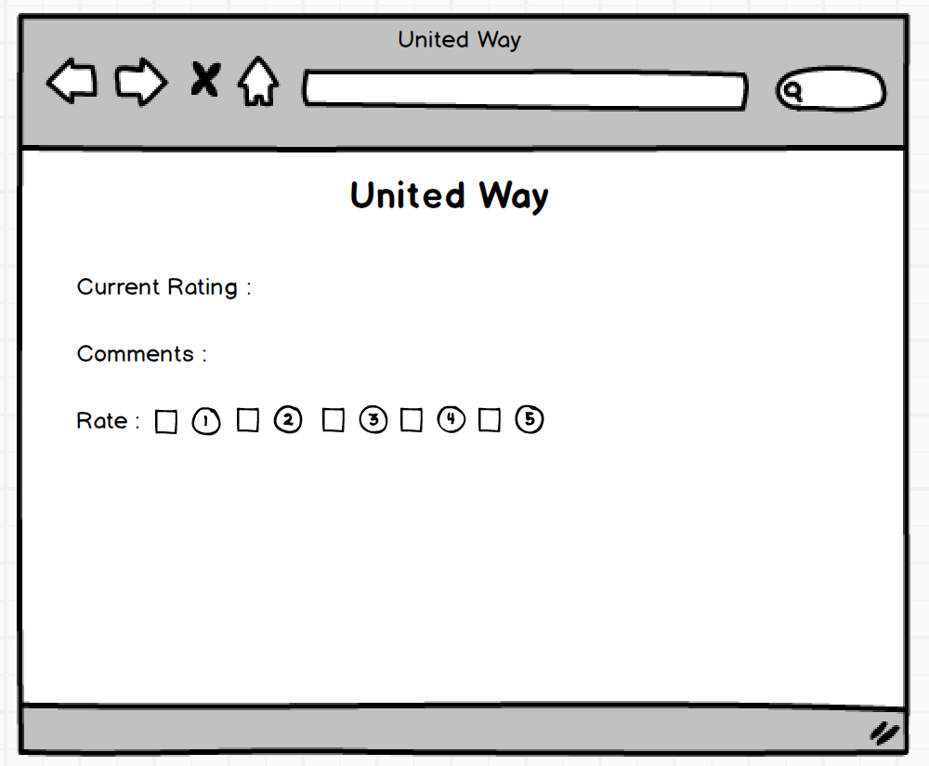

The mock up shown below might be added as an extra page to our website which will represent the performance of charities in terms of some charts and graphs.

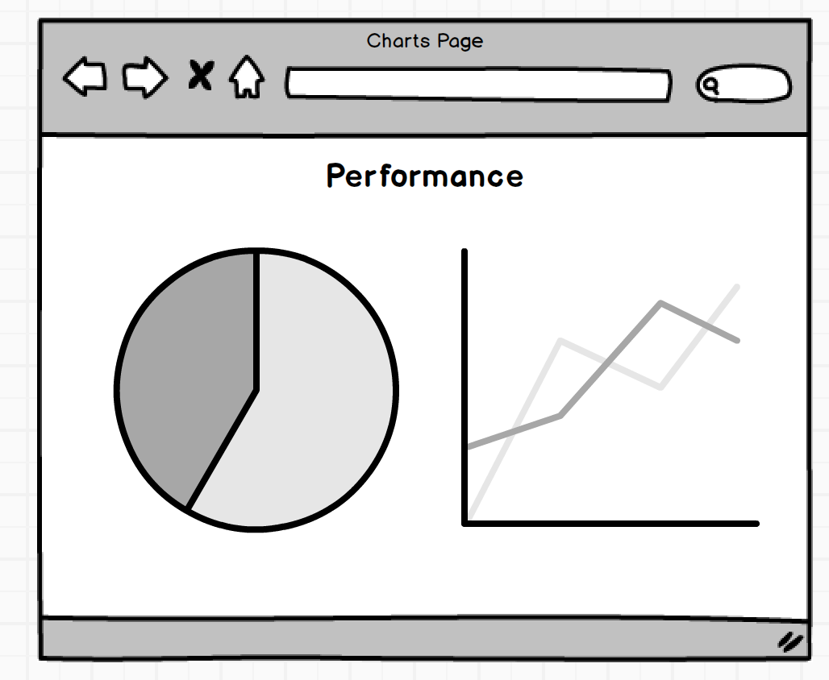

Note - We might add few extra features or modify the ones shown above in the mock-ups. But the overall flow and structure will remain same.